|  |
| --- |
|  |
| Partitioning |

Contents

1. Hands-on task 3

1.1. Adding partition 3

1.2. Coalesce partition 3

1.3. Dropping partition 3

1.4. Merging partition 3

1.5. Moving partition 3

1.6. Splitting partition 3

1.7. Truncating partition 3

2. analytical task 3

# Hands_On Task

* 1. Adding partition(hash partitioning)

While adding a partition to a hash-partitioned table, the database populates the new partition with rows rehashed from an existing partition (selected by the database) as determined by the hash function. Using add partition adds a new hash partition whose partition name is system generated(SYS_P581)

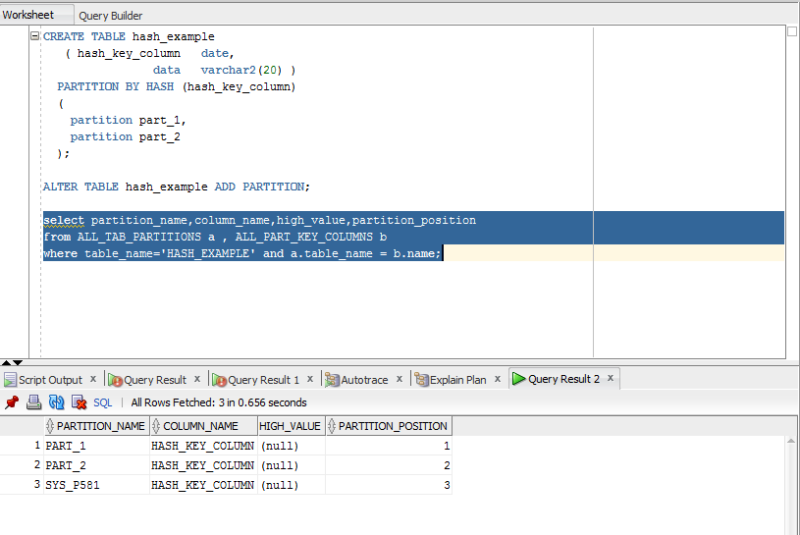

* 1. Coalesce partition(Used only for hash partitioning)

The ALTER TABLE ... COALESCE PARTITION statement is used to coalesce a partition in a hash-partitioned table. The following statement reduces by one the number of partitions in a table by coalescing a partition:

ALTER TABLE Hash_example

COALESCE PARTITION;

In this example oracle union partitions(part_2 and SYS_P581 )

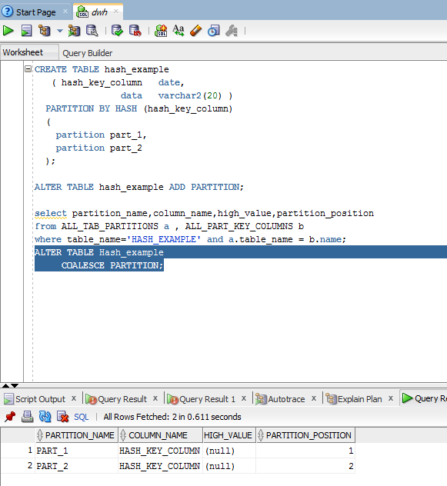

* 1. Drop partition

Created table with range partition because it is impossible to drop hash partition.

CREATE TABLE history_part_r (

history_id NUMBER(10),

person_id NUMBER(10) NOT NULL,

country_id NUMBER(10) NOT NULL,

event VARCHAR2(50),

event_date date,

prof_hist_comments VARCHAR2(2000))

PARTITION BY RANGE (event_date)

(

PARTITION part_1 VALUES LESS THAN(to_date('01-JAN-1000','dd-MON-yyyy')),

PARTITION part_2 VALUES LESS THAN(to_date('01-JAN-2000','dd-MON-yyyy')),

PARTITION part_3 VALUES LESS THAN(to_date('01-JAN-3000','dd-MON-yyyy'))

);

INSERT INTO history_part_r

SELECT

TRUNC(dbms_random.value(1,100),0),

TRUNC(dbms_random.value(1,100),0),

TRUNC(dbms_random.value(1,100),0),

dbms_random.string('A', 20),

TO_DATE(TRUNC(DBMS_RANDOM.VALUE(TO_CHAR(DATE '1-01-01','J'), TO_CHAR(DATE '3000-12-31','J'))),'J'),

dbms_random.string('A', 100)

from dual connect by level <=1000;

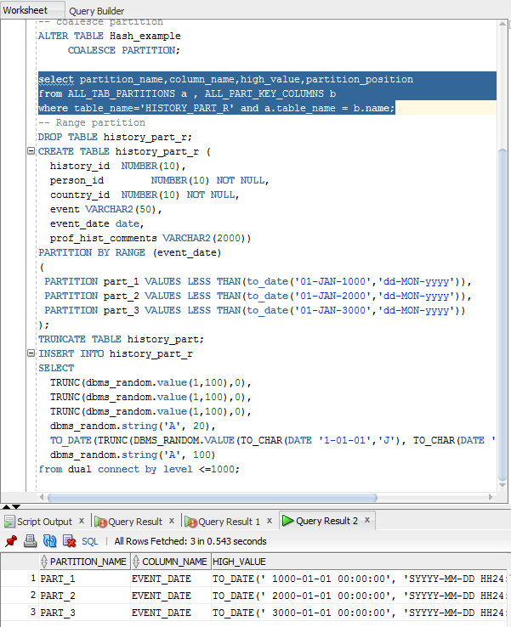

Dropped partition (part_2)

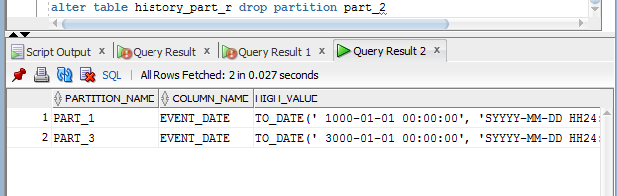

* 1. Merge Partition

Table was created for this situation with 4 partitions

CREATE TABLE four_seasons

(

one DATE,

two VARCHAR2(60),

three NUMBER

)

PARTITION BY RANGE ( one )

(

PARTITION quarter_one

VALUES LESS THAN ( TO_DATE('01-apr-1998','dd-mon-yyyy'))

TABLESPACE quarter_one,

PARTITION quarter_two

VALUES LESS THAN ( TO_DATE('01-jul-1998','dd-mon-yyyy'))

TABLESPACE quarter_two,

PARTITION quarter_three

VALUES LESS THAN ( TO_DATE('01-oct-1998','dd-mon-yyyy'))

TABLESPACE quarter_three,

PARTITION quarter_four

VALUES LESS THAN ( TO_DATE('01-jan-1999','dd-mon-yyyy'))

TABLESPACE quarter_four

);

create tablespace i_quarter_one

DATAFILE 'iquarter1.dat'

SIZE 20M

ONLINE;

create tablespace i_quarter_two

DATAFILE 'iquarter2.dat'

SIZE 20M

ONLINE;

create tablespace i_quarter_three

DATAFILE 'iquarter3.dat'

SIZE 20M

ONLINE;

create tablespace i_quarter_four

DATAFILE 'iquarter4.dat'

SIZE 20M

ONLINE;

CREATE INDEX i_four_seasons_l ON four_seasons ( one,two )

LOCAL (

PARTITION i_quarter_one TABLESPACE i_quarter_one,

PARTITION i_quarter_two TABLESPACE i_quarter_two,

PARTITION i_quarter_three TABLESPACE i_quarter_three,

PARTITION i_quarter_four TABLESPACE i_quarter_four

);

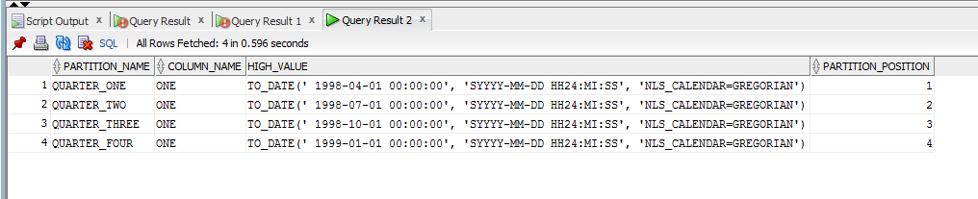

Merge quarter_one and quarter_two:

ALTER TABLE four_seasons

MERGE PARTITIONS quarter_one, quarter_two INTO PARTITION quarter_two

UPDATE INDEXES

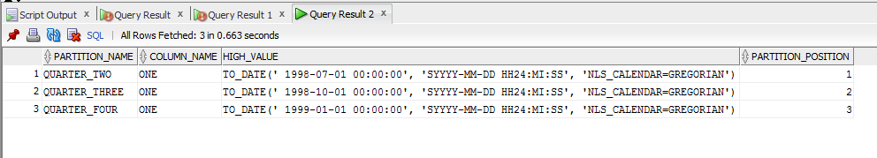

Rebuild index for quarter_two, which has been marked unusable because it has not had all of the data from Q1 added to it.

Rebuilding the index corrects this.

ALTER TABLE four_seasons MODIFY PARTITION

quarter_two REBUILD UNUSABLE LOCAL INDEXES;

* 1. Move Partition

Before moving partition quarter_four it is situated in quarter_four tablespace



ALTER TABLE four_seasons MOVE PARTITION Quarter_four

TABLESPACE tbs_pdb_test NOLOGGING COMPRESS;



After that quarter_four is situated in tbs_pdb_test

* 1. Splitting partition

Before splitting partitions:



ALTER TABLE history_part_r

SPLIT PARTITION FOR(TO_DATE('01-MAY-2007','dd-MON-yyyy'))

AT (TO_DATE('15-MAY-2007','dd-MON-yyyy'));



After splitting partition appear one more partition (between 3000 and 2007)

* 1. Truncating partition

Situation before truncating partition :

ANALYZE TABLE history_part_r COMPUTE STATISTICS;

SELECT table_name, partition_name, high_value, tablespace_name, blocks, num_rows

FROM user_tab_partitions ORDER BY TABLE_NAME;



ALTER TABLE history_part_r TRUNCATE PARTITION part_1;



As we can see after truncating part_1 in this partition no existing rows